Model Development Phase Template
Date | 30 June 2025
Team ID | LTVIP2025TMID47084
Project Title | Revolutionising Liver Care- Predicting Liver Cirrhosis using advanced Machine Learning
Maximum Marks | 4 Marks
Initial Model Training Code, Model Validation and Evaluation Report
The initial model training code will be showcased in the future through a screenshot. The model validation and evaluation report will include classification reports, accuracy, and confusion matrices for multiple models, presented through respective screenshots. Initial Model Training Code:

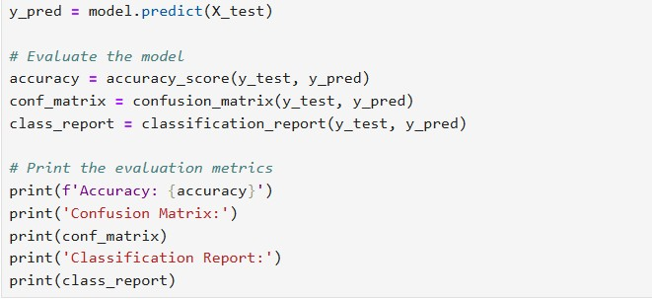
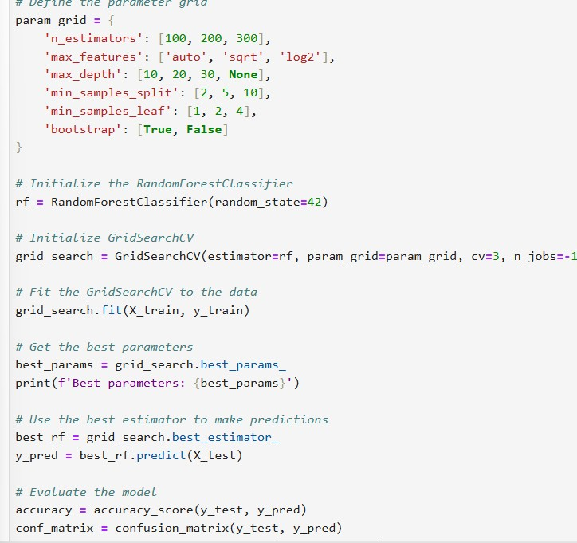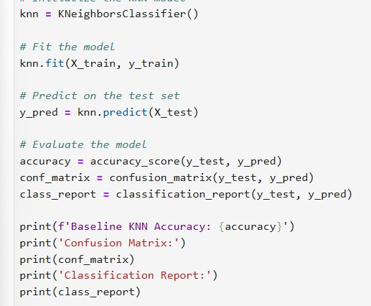

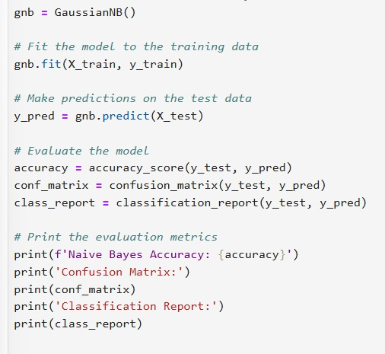
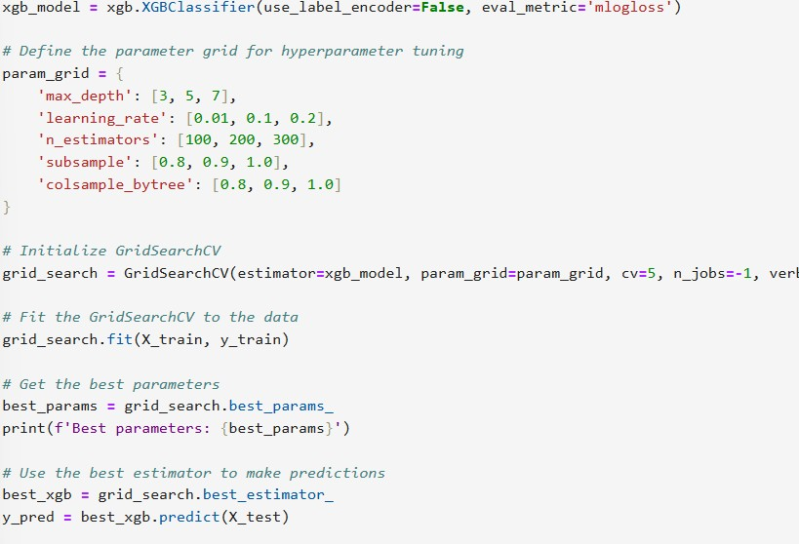
Model | Classification Report | F1  Scor e | Confusion Matrix
Random  Forest | 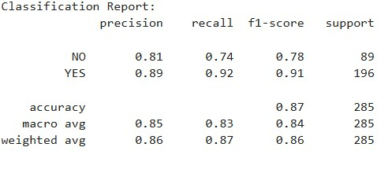 | 86% | 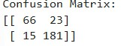
Model Validation and Evaluation Report:

Naïve Bayes | 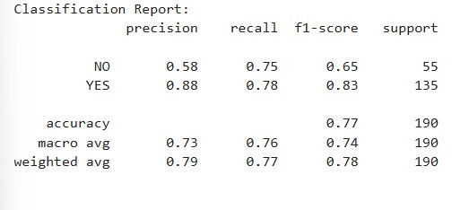 | 78% | 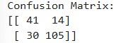
KNN | 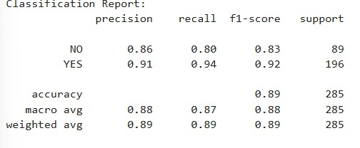 | 89% | 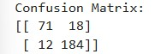

Xg  Boost | 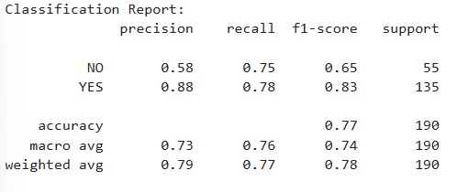 | 78% | 